Hands-On Lab
Lab Manual
A Quick Portlet Tutorial.

Record of change

*A - Added M - Modified D – Deleted

Effective Date | PIC | A*  M, D | Change Description | New Version
10-Dec-2011 | Thach.Le | A | Create. | 0.1

Contents
A Quick Portlet Tutorial. i
Lab 01: A quick portlet tutorial 5
Lab Objectives 5
Prerequisite: 5
Exercise 1 – Download & install Eclipse and necessary plugins. 6
1. Prepare the Eclipse JEE IDE with plugin Eclipse Portal Pack 2.0.1 6
2. Prepare Glashfish with add-on Open Portlet Container 6
Download Glassfish 3.0.1 at http://glassfish.java.net/downloads/3.0.1-final.html 6
Installing the Glassfish with adjust port 9090 6
3. Configure the server for Eclipse. 6
Exercise 2 – Create Hello Portlet. 9
1. Create a Dynamic Web Application. 9
2. Change default Context root (HelloPortlet) into to portletdriver/dt (all lowcases) 9
3. Create portlet HelloPortlet. 11
4. Input information for HelloPortlet 12
3. Modify the JSPs. 13
4. Look over the web.xml. 13
5. Run the web application. 14
6. Open the portlet in the browser. 15
Trouble shooting 16
1. Issue #1: In case the error is displayed as bellow: 16
2. Issue #2: Stop the Glashfish within Eclipse 16
3. Issue #3: In case your browser (default is the built-in browser of the Eclipse) could not display the HelloPortlet immediately, please wait a minutes (monitor the Portal starting in the tab Console), then click on Home link. 16
4. Issue #4: For some version of Windows, Eclipse, Linux the status of the OpenPortal Portlet Container is displayed correctly as the below screen 16
Lab 02: Deploy the portlet into the uPortal 17
Lab Objectives 17
Exercise 1 – Pack the portlet. 18
1. Export the .war file. 18
2. Deploy the HelloPortlet.war into the uPortal. 18
Create folder “DeployPortlet” below folder “uPortal-4.0.2-quick-start” 18
Create file “DeployHelloPortlet.bat” in folder “DeployPortlet” following content: 18
Copy file “HelloPortlet.war” which are generated in step 1 into the folder “uPortal-4.0.2-quick-start/DeployPortlet”. 18
Change the working folder into “uPortal-4.0.2-quick-start/DeployPortlet”. Then execute script “DeployHelloPortlet.bat” 18
Exercise 2 – Publish the portlet. 20
1. Download uPortal Developer Quick Start 4.0.2 at http://www.jasig.org/uportal/download 20
2. Start the uPortal 20
3. Login the uPortal with account admin/admin.
In tab Admin Tools, click on “Manage portlets” link 21
4. On screen Portlet Registration screen, click on button “Register New Portlet”. 21
5. Select Type: Portlet 22
6. Select the Portlet to publish 22
7. Input information for this channel as following. 23
Channel Title: HelloPortlet 23
Channel Name: HelloPortlet 23
Channel Functional Name: HelloPortlet 23
Channel Description: Your description 23
Channel Timeout: 50000 23
8. Screen Select Categories is displayed 23
9. On screen “Select People and Groups”, select group “Everyone” by click on Add icon in right-side of Everyone. 24
10. On screen Lifecycle Management, select State “Published”. 25
Exercise 3 – Using Portlet 26
1. Create a new tab “Test Portlet” by click “+ Add Tab” link. 26
2. Using the portlet 26
3. Click on Done link. 27
Appendix 28
1.Setup necessary environment variables. 28
For Windows: 28
Create JAVA_HOME variable: 28
Open Environment Variables window: 28
Create ANT_HOME variable: 28
Edit PATH variable as following: 29
For Linux: 29
2.Install Glassfish Server Open Source Edition Web Profile 3.0.1 30
3.Install Portlet Container for Glassfish 32

Lab 01: A quick portlet tutorial
Estimated time to complete this lab: 45 minutes

Lab Objectives
The objective of this lab is to introduce you how to create a simple portlet.
- Prepare the development environment with Eclipse, Glashfish.
- Writing a HelloPortlet.
- Deploy the portlet into uPortal.

References:
- https://open-ones.googlecode.com/svn/trunk/OOG-Handbook/Hands-on%20Labs/J2EE.
- ANT tool (http://ant.apache.org) is already.

Prerequisite:
- Completed the exercise 1 at https://docs.google.com/open?id=0B4vjYnf6j5_4ZDMzY2NhM2MtMDBlMy00OWE1LWE4MDUtNGNkMWJlYzczMjAy (You should use JDK 6 build 13 or later)

Exercise 1 – Download & install Eclipse and necessary plugins.
  - Prepare the Eclipse JEE IDE with plugin Eclipse Portal Pack 2.0.1
- View http://code.google.com/p/open-ones/wiki/PrepareIDEEclipse
  - Prepare Glashfish with add-on Open Portlet Container
  - Download Glassfish 3.0.1 at http://glassfish.java.net/downloads/3.0.1-final.html
  - Installing the Glassfish with adjust port 9090
- Install Glassfish v3.0.1 and Open Portlet Containter (Refer Appendix)

Refer more details in Appendix.
  - Configure the server for Eclipse.
- Open the Preferences dialog by going to menu Window > Preferences, select node Server\Runtime Environment.
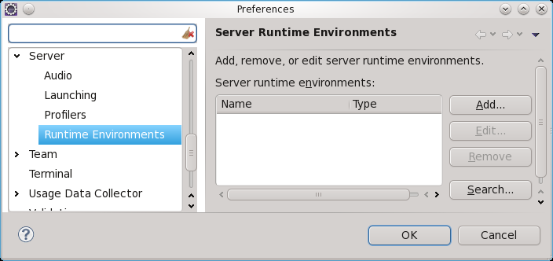
Click on Add… button.
- In the New Server Runtime Environment dialog, select node Sun Microsystems\OpenPortal Portlet Container 2.x.
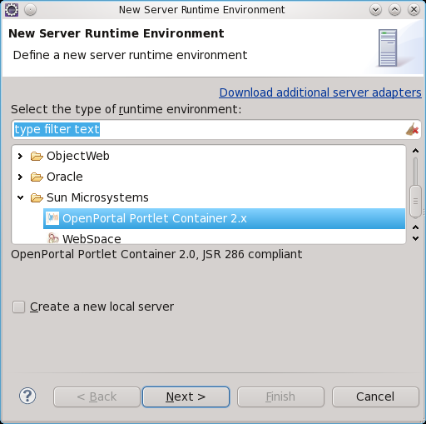
- Click on “Browse…” button to select Glassfish Home.
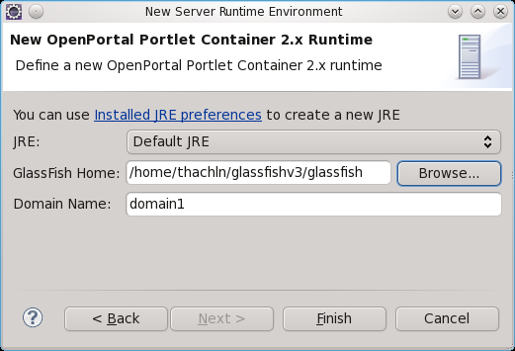
Click on Finish button.

- The OpenPortal Portlet Container has been added to server runtime environment.
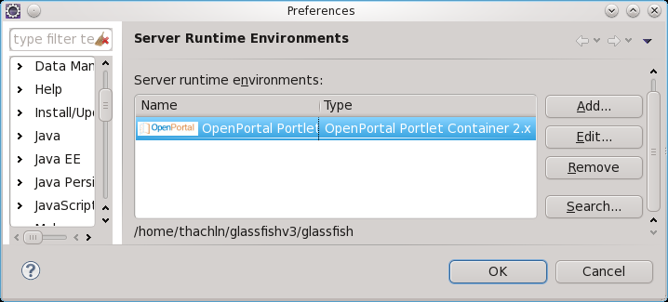

Exercise 2 – Create Hello Portlet.
  - Create a Dynamic Web Application.
- Going to menu File > New > Dynamic Web Project.
  - Input the Project name. Click on Next button twice.
- Select Portlet 1.0 support in Configuration listbox.

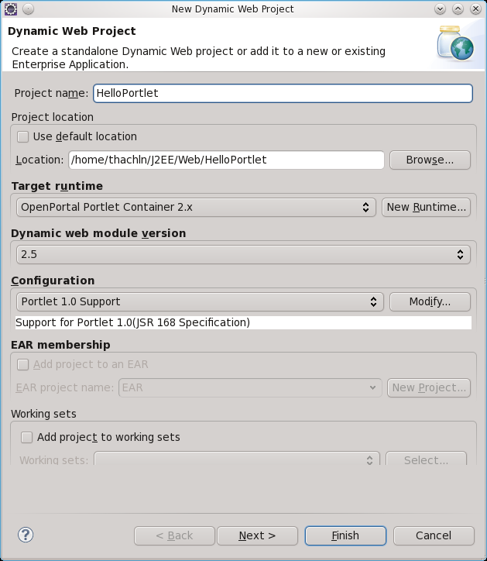
Click on Finish button -> Next button.
  - Change default Context root (HelloPortlet) into to portletdriver/dt (all lowcases)
In “Configure web module settings”, modify Context root : portletdriver/dt
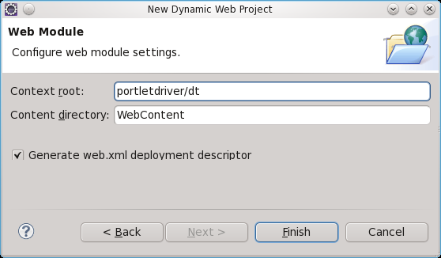
- Click on Finish button. The structure of the project is following:
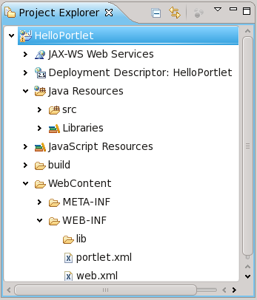
- Create portlet HelloPortlet.
- Open New Java Portlet by press Ctrl+N
- Select node Portlet\Java Portlet.
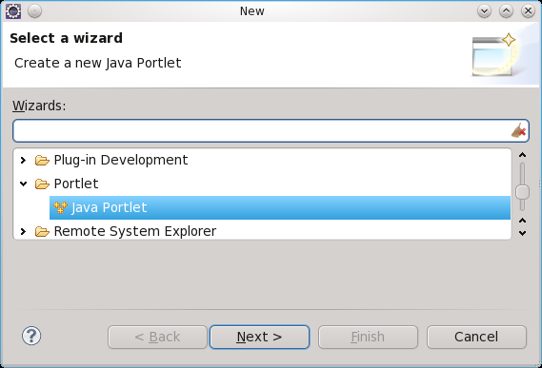
- Click on Next button.

  - Input information for HelloPortlet
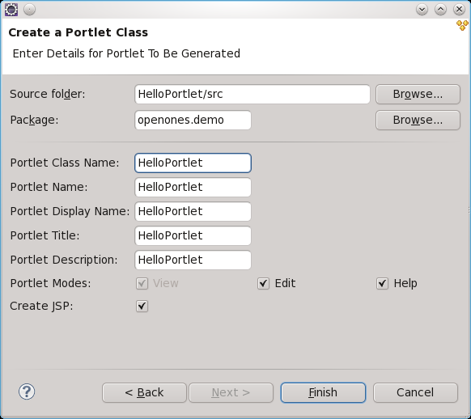
Click on Finish button.
The skeleton of HelloPortlet is generated as below:
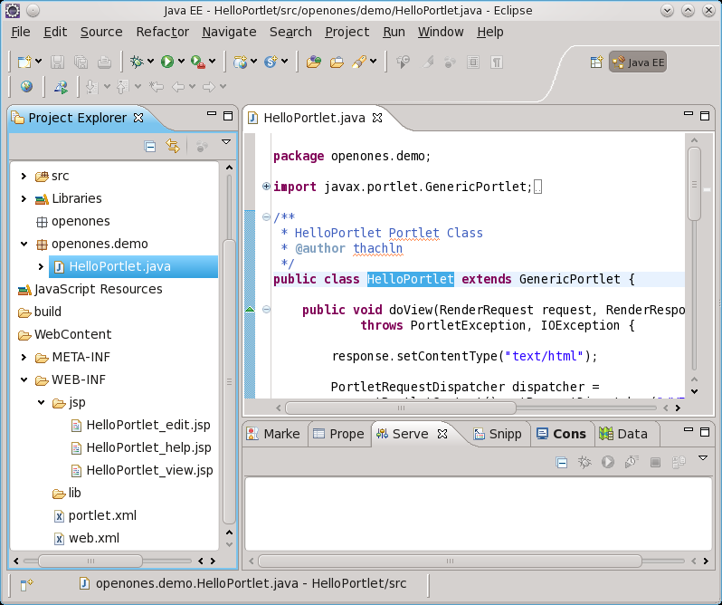
  - Modify the JSPs.
- Open the HelloPortlet\WebContent\WEB-INF\jsp\HelloPortlet_view.jsp file:
<%@page contentType="text/html"%>
<%@page pageEncoding="UTF-8"%>

<%-- Uncomment below lines to add portlet taglibs to jsp
<%@ page import="javax.portlet.*"%>
<%@ taglib uri="http://java.sun.com/portlet_2_0" prefix="portlet"%>

<portlet:defineObjects />
--%>

<b>
VIEW MODE
</b>
- Replace taglib uri="http://java.sun.com/portlet_2_0" by
taglib uri=http://java.sun.com/portlet”
  - Look over the web.xml.
- Open HelloPortlet\WebContent\WEB-INF\portlet.xml file, look over its content.
<?xml version='1.0' encoding='UTF-8' ?>
<portlet-app xmlns='http://java.sun.com/xml/ns/portlet/portlet-app_1_0.xsd' xmlns:xsi='http://www.w3.org/2001/XMLSchema-instance' xsi:schemaLocation='http://java.sun.com/xml/ns/portlet/portlet-app_1_0.xsd http://java.sun.com/xml/ns/portlet/portlet-app_1_0.xsd' version='1.0'>
<portlet>
<description>HelloPortlet</description>
<portlet-name>HelloPortlet</portlet-name>
<display-name>HelloPortlet</display-name>
<portlet-class>openones.demo.HelloPortlet</portlet-class>
<expiration-cache>0</expiration-cache>
<supports>
<mime-type>text/html</mime-type>
<portlet-mode>VIEW</portlet-mode>
<portlet-mode>EDIT</portlet-mode>
<portlet-mode>HELP</portlet-mode>
</supports>
<resource-bundle></resource-bundle>
<portlet-info>
<title>HelloPortlet</title>
<short-title>HelloPortlet</short-title>
</portlet-info>
</portlet>
</portlet-app>

  - Run the web application.
- Right-click on the project, select Run As > Run on Server.
- Select server type: OpenPortal Portlet Containter 2.x
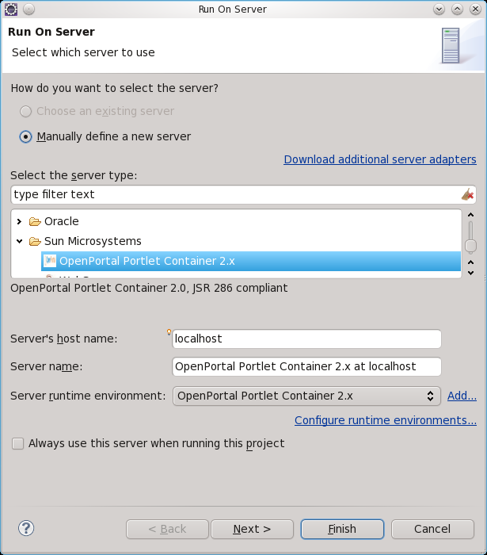
Click on Next button. Then adjust the Server Port into 9090. Click on Finish button.
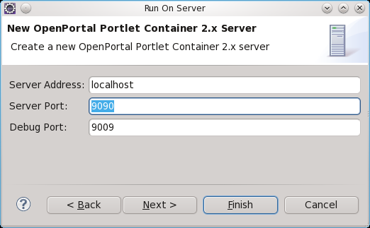
  - Open the portlet in the browser.
- Open the browser with the url: http://localhost:9090/portletdriver/dt
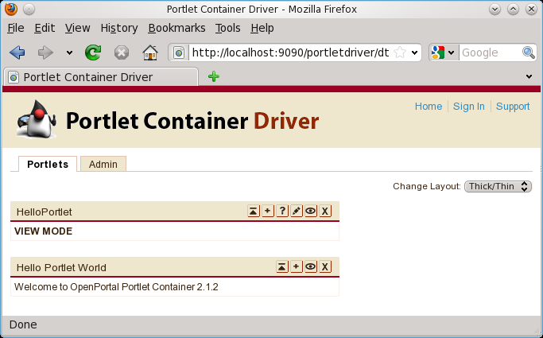
Here is the content HelloPortlet.

Trouble shooting
  - Issue #1: In case the error is displayed as bellow:
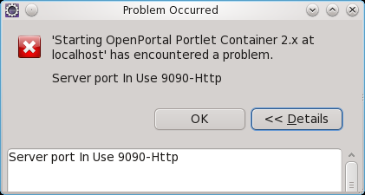
Please check to stop the Glashfish which can be run standalone at port 9090. In case the Glashfish you have started within Eclipse before, stop it please. Then try to run the HelloPortlet again.
  - Issue #2: Stop the Glashfish within Eclipse
Select tab “Server” at bottom panel (If it is invisible, going to Window > Show View > Servers), select the OpenPortal Portlet Containter 2.x at localhost. Then click on Stop sign (the red rectangle at the top right of the panel).
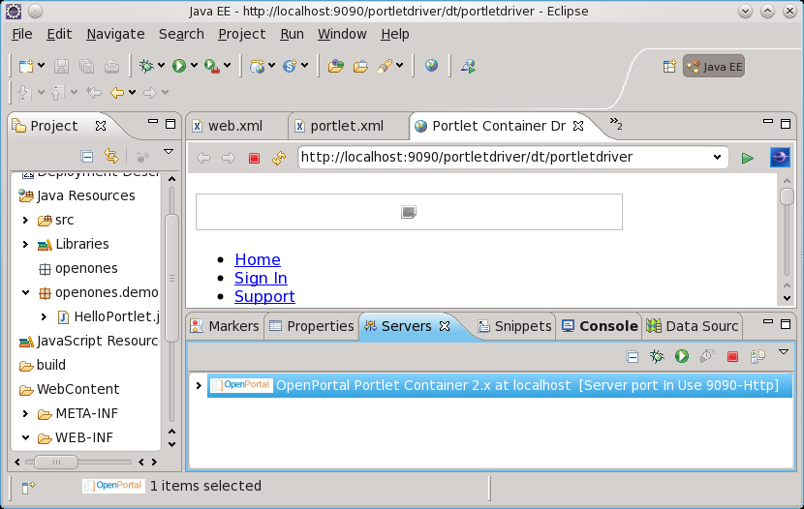
  - Issue #3: In case your browser (default is the built-in browser of the Eclipse) could not display the HelloPortlet immediately, please wait a minutes (monitor the Portal starting in the tab Console), then click on Home link.
  - Issue #4: For some version of Windows, Eclipse, Linux the status of the OpenPortal Portlet Container is displayed correctly as the below screen

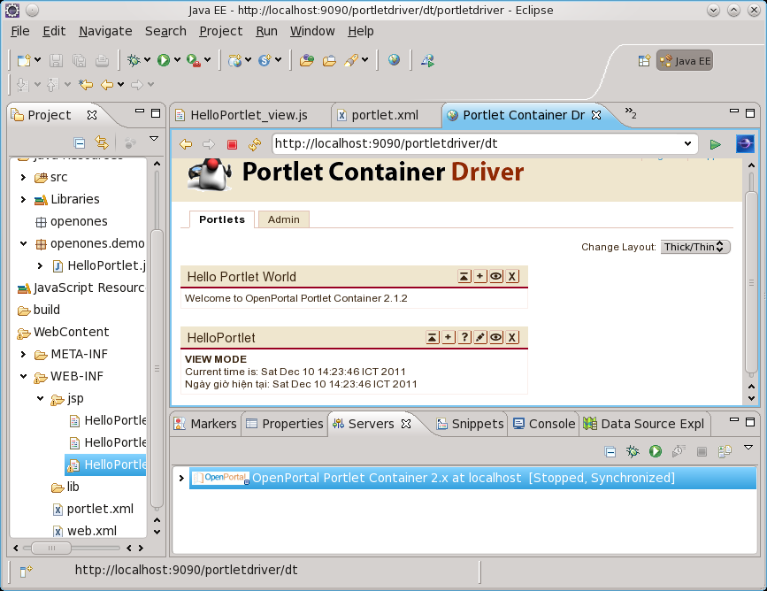
It' status is [Stopped] while it is running. If you update code and want to re-run the portlet, you start it again by click run green right arrow (Play icon) to receive an error message as the issues #1. Click on OK to close the error dialog, now the Stop icon is enable. Click on it to stop
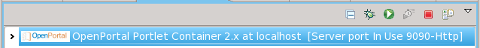
Lab 02: Deploy the portlet into the uPortal
Estimated time to complete this lab: 30 minutes

Lab Objectives
The objective of this lab is to introduce you how to deploy the portlet into uPortal.
- Pack the portlet into the .war file.
- Deploy the portlet into the uPortal.

Exercise 1 – Pack the portlet.
  - Export the .war file.
- Right-click on the project, select Export > WAR file.
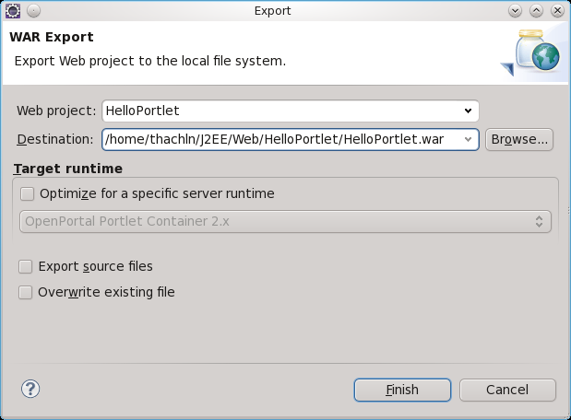
  - Deploy the HelloPortlet.war into the uPortal.
  - Create folder “DeployPortlet” below folder “uPortal-4.0.2-quick-start”
  - Create file “DeployHelloPortlet.bat” in folder “DeployPortlet” following content:
cd ../uPortal-4.0.2
ant deployPortletApp -DportletApp="../DeployPortlet/HelloPortlet.war"
For Linux, create script “DeployHelloPortlet.sh” with the same above content. Add the executable attribute by command:
chmod +x DeployHelloPortlet.sh
  - Copy file “HelloPortlet.war” which are generated in step 1 into the folder “uPortal-4.0.2-quick-start/DeployPortlet”.
  - Change the working folder into “uPortal-4.0.2-quick-start/DeployPortlet”. Then execute script “DeployHelloPortlet.bat”
For Linux, executable script DeployHelloPortlet.sh command:
./DeployHelloPortlet.sh
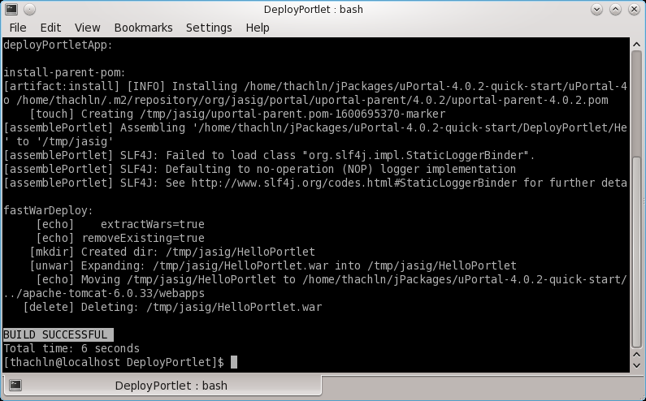

Exercise 2 – Publish the portlet.
  - Download uPortal Developer Quick Start 4.0.2 at http://www.jasig.org/uportal/download
  - Start the uPortal
For Windows, open the Command Line window, change the working folder into the uPortal-4.0.2-quick-start folder, execute command
and start
For Linux, open the shell console, change the working folder into the uPortal-4.0.2-quick-start folder, execute command
and start

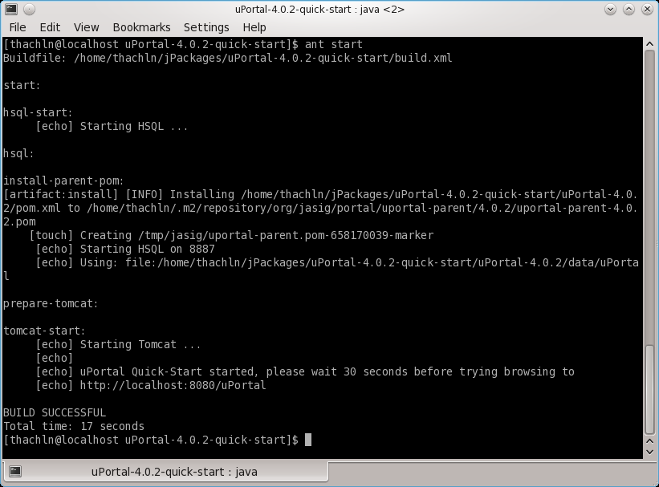
Your can browse the uPortal is at link http://localhost:8080/uPortal
  - Login the uPortal with account admin/admin.
In tab Admin Tools, click on “Manage portlets” link
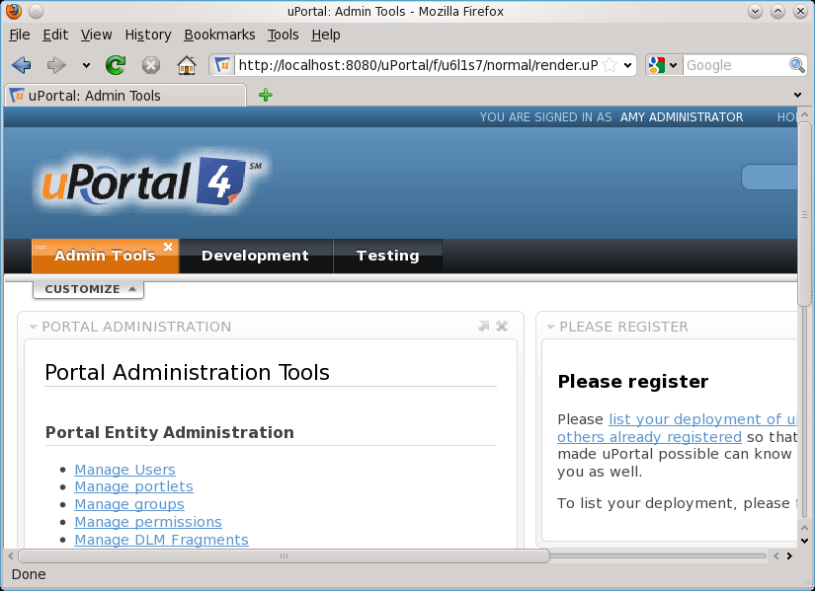
  - On screen Portlet Registration screen, click on button “Register New Portlet”.
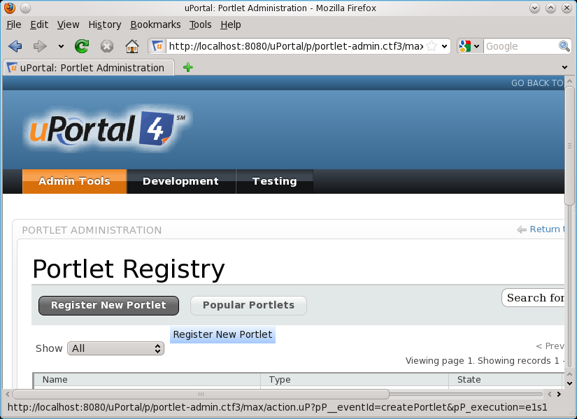
  - Select Type: Portlet
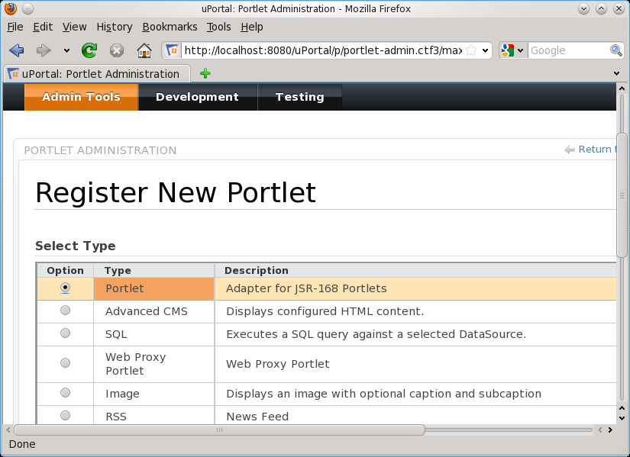
Click on Next button.
  - Select the Portlet to publish
The uPortal recognized the deployed web app “HelloPortlet” by file HelloPortlet.war and portlet “HelloPortlet” by the file portlet.xml below folder “WEB-INF” of the war file.
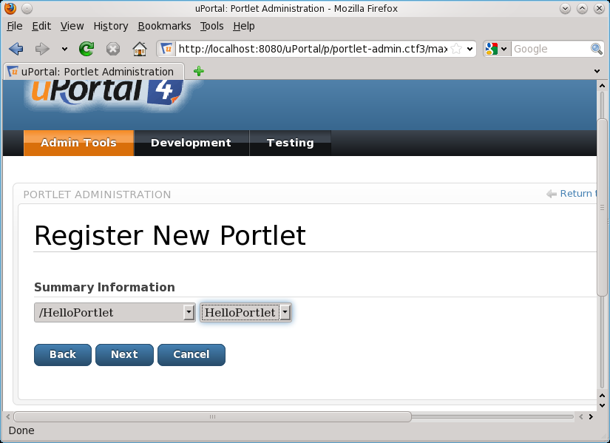
Select the application “/HelloPortlet” in the first combo box and the portlet “HelloPortlet” in the second combo box. Then click on Next button.
  - Input information for this channel as following.
- Channel Title: HelloPortlet
- Channel Name: HelloPortlet
- Channel Functional Name: HelloPortlet
- Channel Description: Your description
- Channel Timeout: 50000
- Click on Next button twice.
  - Screen Select Categories is displayed
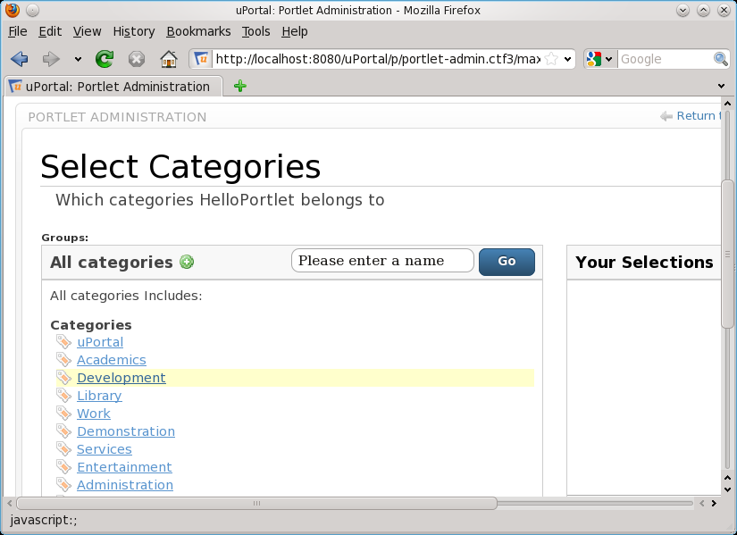
Select Category “Development”. Then click on Add icon at the end category name “Development”.
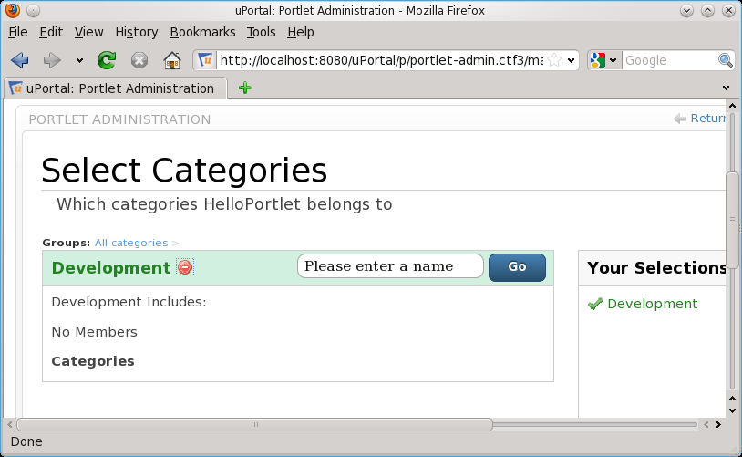
Then click on Next button.
  - On screen “Select People and Groups”, select group “Everyone” by click on Add icon in right-side of Everyone.
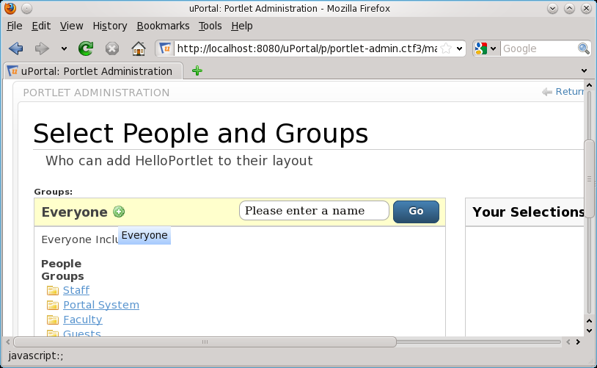
Click on Next button.
  - On screen Lifecycle Management, select State “Published”.
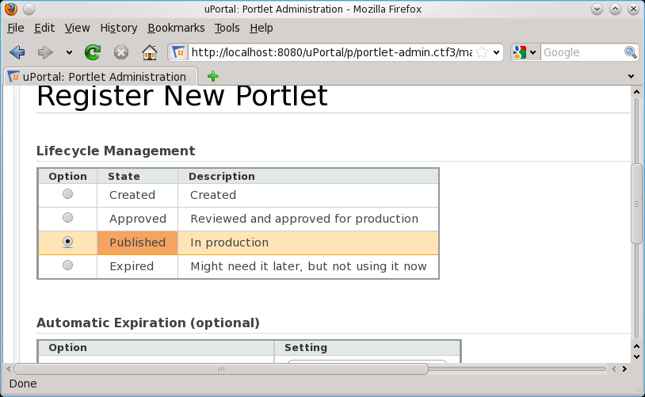
Click on Next button. Review all information then click on Save button to complete the Register Portlet successfully.
You can select Show “Development” to review the registried portlet.
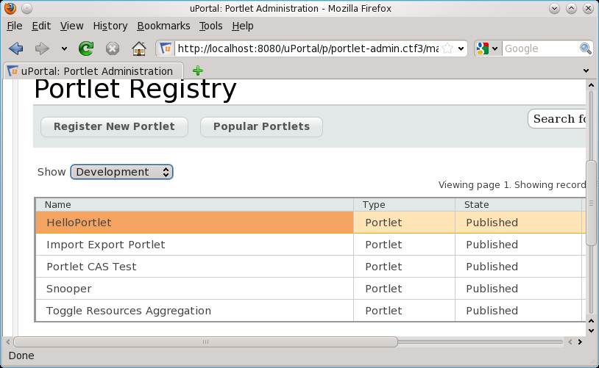

Exercise 3 – Using Portlet
You can current account Admin to try to use the portlet.
  - Create a new tab “Test Portlet” by click “+ Add Tab” link.
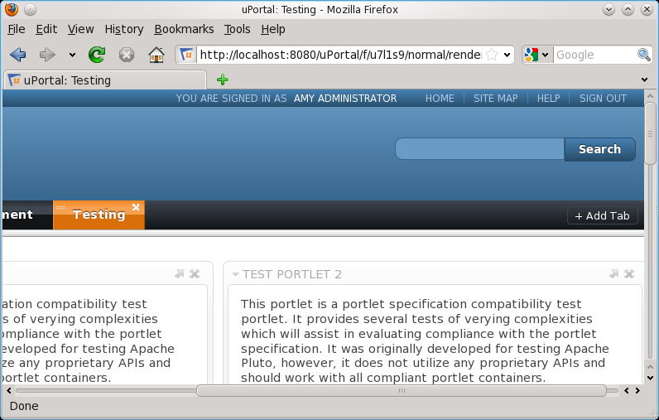
  - Using the portlet
Within the tab, click on “CUSTOMIZE > Add Stuff”, select Development in CATEGORIES, click on Add button at the top right of the HelloPortlet.

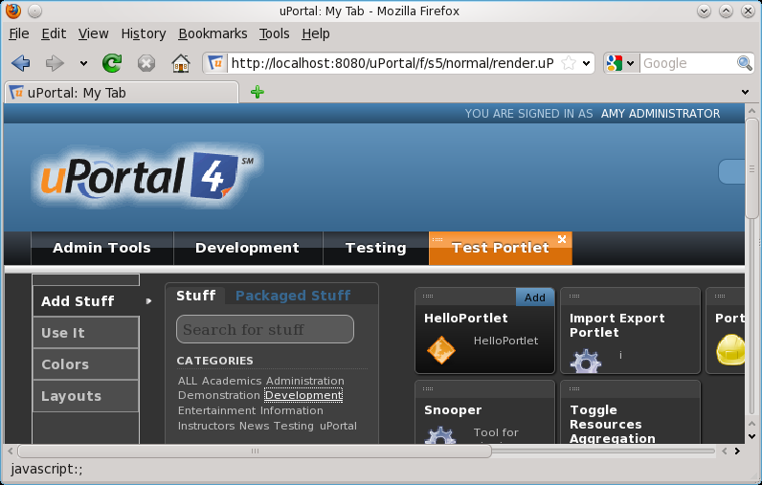
  - Click on Done link.
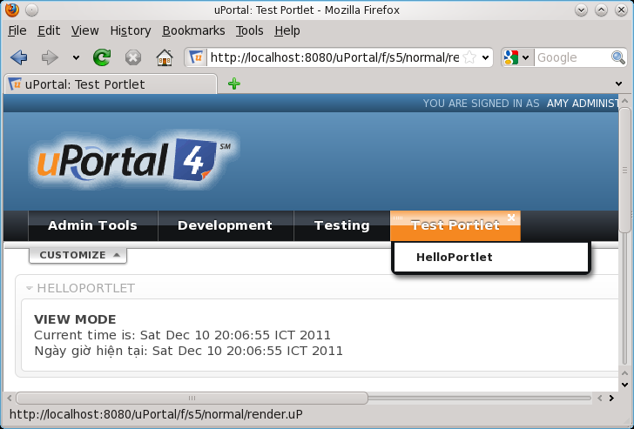
Appendix

Setup necessary environment variables.

For Windows:
- Create JAVA_HOME variable:
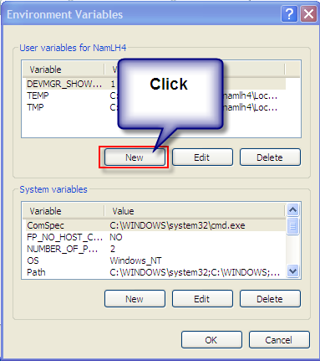
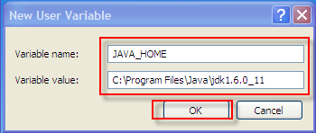
  - Open Environment Variables window:

- Create ANT_HOME variable:
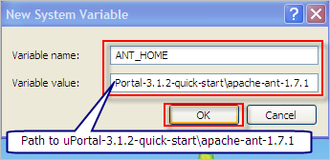
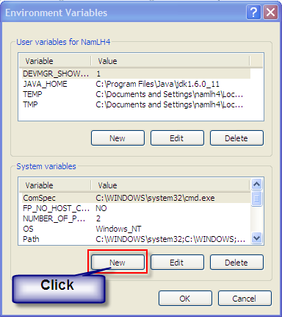

- Edit PATH variable as following:

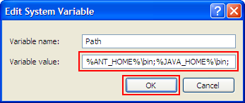
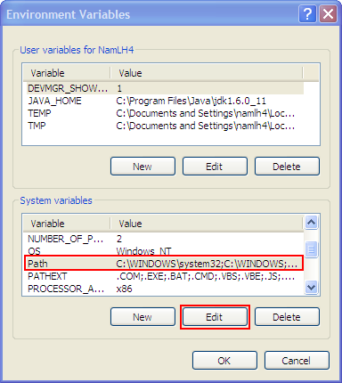

For Linux:
Create a executable shell script /etc/profile.d/java.sh following sample content:
#/bin/sh
export JAVA_HOME=/opt/jdk1.6.0_27
export PATH=$JAVA_HOME/bin:$PATH
export ANT_HOME=/home/thachln/jPackages/apache-ant-1.8.2/
export PATH=$ANT_HOME/bin:$PATH

Install Glassfish Server Open Source Edition Web Profile 3.0.1
- For Windows, double click on glassfish-3.0.1-web-windows.exe.
- For Linux
Add executable for script by using command: chmod +x
chmod +x glassfish-3.0.1-web-unix.sh
Install by execute
./glassfish-3.0.1-web-unix.sh

Setting during installing the Glashfish
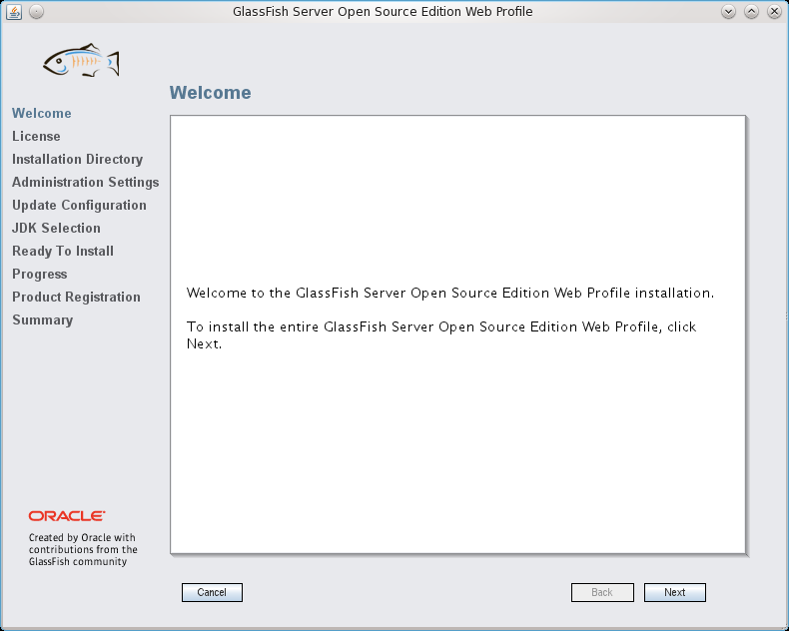
Follow the screen guideline in next steps.
In the Administration Setting screen, change port of the Glassfish into 9090.
Change Admin Port to: 4949
Http Port to: 9090
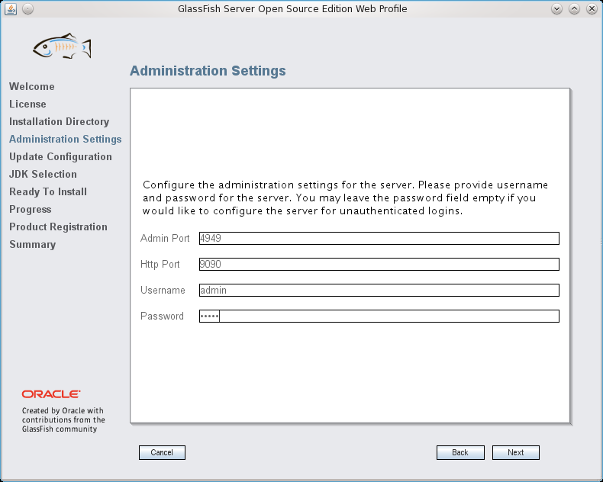
Follow the screen guideline to complete the installing.

Install Portlet Container for Glassfish
- Download load Open Portlet Container at http://portlet-container.java.net/public/Download.html
- Run the OPC by execute command:
java -jar portlet-container-configurator.jar
- Select Glassfish for Container, select the ANT home tool and Glashfish home directory. Then click on OK.
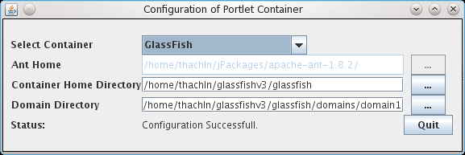
Note: Selected Glassfish home directory is folder contains “domains/domain1”.

